Ankeny Little League Safety Program & Manual

2022

Section(s) | Description | Date Approved
All | 2022 Program Executive Board Approval | Feb. 6, 2022
Severe Weather Policy | Executive Board Approval | Feb. 6, 2022

About Ankeny Little League

Ankeny Little League is a youth baseball organization serving the community of Ankeny residing within Iowa Little League District 3 and chartered by Little League Baseball, Inc. (LLBI) in Williamsport, Pennsylvania. Ankeny Little League provides a baseball opportunity to over 1000 players annually from Tee Ball to the Senior level. All games are played at the Prairie Ridge Sports Complex on 16 different baseball diamonds.

- League Charter: 1150324

Ankeny Little League
PO Box 165
Ankeny, IA 50021

Ankeny Little League Mission Statement

Ankeny Little League is committed to fostering the ideals of sportsmanship, hard work and respect through our community-based youth baseball programs. We will endeavor to support and develop these character traits within our participants, volunteers and guests within a safe, family-oriented environment. We will strive to have fun while providing baseball skills development, healthy competition, respect and appreciation for the game of baseball.

Little League Pledge

I trust in God
I love my country
And will respect its laws
I will play fair
And strive to win
But win or lose
I will always do my best

The Little League Parent/Volunteer Pledge

I will teach all children to play fair and do their best
I will positively support all managers, coaches and players
I will respect the decisions of the umpires
I will praise a good effort despite the outcome of the game

Table of Contents

Introduction 4
The Program 5
Safety Director 5
Safety Manual 5
Emergency Response Contacts 5
2022 Executive Board 6
Little League Board & Board Committees 6
Background Checks 8
Severe Weather 9
WEATHER ALERT SYSTEM NOTIFICATIONS 9
LIGHTNING 10
ALL CLEAR 11
TORNADO WATCH OR WARNING 11
COLD WEATHER GUIDELINES 11
HOT WEATHER GUIDELINES 12
Baseball Fundamentals Training 12
Umpire Training 12
First Aid and Emergency Response Training 12
Field/Facility Inspections 13
Annual Facility Survey 13
Concession Stand Safety 14
Equipment Inspections 14
Accident Reporting Procedure 14
Player Concussion Requirements and Procedure 15
First Aid Kits 16
Rules Enforcement 17
Qualified Safety Plan Registration Form 17
League Player Registration Data or Player Roster Data & Manager/Coach Data 18
Medical Release Forms 18
Fire Extinguishers 18
Utility Vehicles (Golf Carts) Safety 18
Additional Safety Precautions at Prairie Ridge Sports Complex 19
Safety Precautions 19
Addendums – Ankeny Little League Forms 23
Appendices – General Safety Information 23

Introduction

Ankeny Little League is committed to fostering safety within its youth baseball programs. To support this commitment, the Ankeny Little League Board of Directors (the Board) has approved the following safety program. We will implement the safety program outlined in this document. This program is aligned with requirements and recommendations given by Little League International ASAP (A Safety Awareness Program).

ASAP Mission Statement:

To increase awareness of the opportunities to provide safer environment for kids and all Little League participants.

Ankeny Little League Safety Program Primary Goals:

- Injury Prevention
- Injury Severity Reduction
- Injury Response

We will support the ASAP Mission Statement and promote safety within our league through the following means:

- Instruction and Education
- Inspection
- Maintenance and Repair
- Reporting and Response
- Continuous Improvement

2022 ASAP Minimum Requirements:

- Have active Safety Director on file with Little League International
- Publish to the league website and notify the volunteers
- Distribute emergency and key official contact information to each Team
- Conduct background checks on all volunteers through JD Palatine (JDP)
- Provide baseball fundamentals training for players and coaches
- Provide first aid training for managers and coaches
- Require managers/umpires to conduct field/facility inspections and repair/maintenance before practice and game use
- Complete 2022 Annual Little League Facility Survey
- Written safety procedures for concession stand; concession manager trained in safe food handling/prep and procedures
- Require pre-season/regular equipment inspection and repair/maintenance procedures
- Implement prompt accident reporting and tracking procedure
- Require a first aid kit at all games and practice events
- Enforce all Little League Baseball Rules including proper equipment
14. League Player Registration Data or Player Roster Data, Coach and Manager Data using Little League Data Center
15. This requirement requests that local league report their best safety practices and any recent initiatives to better the Little League experience.
16. Qualified Safety Plan Registration Form

The Program

Safety Director

The position of Safety Director has been established by the Board. This is an executive level position that is responsible for administration and oversight of all Ankeny Little League safety programs and initiatives.

For 2022, this position is held by Matthew Kann, 319-750-9966, matthew.kann@yahoo.com

***********************

Safety Manual

The Executive Board has authorized the development of this League Safety Manual. The Safety Director will be responsible for the development and maintenance of this manual. The Safety Director will bring the manual before the Executive Board for approval each year or when it has been modified or revised. This approval and the date will be noted on the cover of the manual. When it is approved, it will be distributed by publishing it to the league’s website and a paper copy is maintained in the league’s Quad Center and main concession stand.

All league officials, managers, coaches, parents, umpires and concession workers are strongly encouraged to review the manual by visiting the website, Quad Center or concession stand. Those individuals that do not have access to the website may request a printed copy from the Safety Director.

This Ankeny Little League Safety Program Manual will be filed with Little League International.

***********************

Emergency Response Contacts

Ankeny Police
- Emergency: 911
- Non-emergency: 515-286-3333

Ankeny Fire Department and Emergency Medical Services
- Emergency: 911
- Non-emergency: 515-965-6469

These phone numbers will be posted in the Quad Center, concession stand and will be included with all team first aid kits.

When calling the Ankeny Police or Ankeny Fire, it is important to include information for the responders to locate the emergency. When at the Prairie Ridge Baseball Complex, always include detailed information to locate the emergency, such as a field number or a building name.

It is also important to send a designated individual to the parking lot entrance to help direct the responders to the correct location.

***********************

2022 Executive Board
President
- Rob Sheeks (515) 707-1689 woobbee@msn.com

Past President
- n/a

VP – Intermediate/Junior/Senior League
- Chris Riemann (515) 473-5214 reimann@gmail.com

VP - Little League (A - AAA)
- Brian Tournier (515) 661-1397 btournier@yahoo.com

VP - Pre-Little League (Tee Ball – Coach Recovery (Rookies))
- Brad Rolling (515) 720-4984 sbrolling@gmail.com

VP – District 3 / Little League Representative
- Becky Simmons (515) 250-7491 bdsimms_3@msn.com

Treasurer
- Jason Victor (515) 250-9016 jasonvictor@mchsi.com

Secretary
- Janean Carey (515) 210-3332 janean.carey@yahoo.com

Player Agent (A – Senior)
- Steve Nuzum (515) 306-9739 steve.nuzum@gmail.com

Player Agent (TB – CR)
- Steve Nuzum (515) 306-9739 steve.nuzum@gmail.com

Safety Director
- Matthew Kann (319) 750-9966 matthew.kann@yahoo.com

Little League Board & Board Committees
Policy and Ethics Committee
- Open

Fundraising and Sponsorship
- Jeff Wilson (515) 707-0644 jefferywilson23@gmail.com

Facilities Maintenance and Planning
- Open

Uniforms Manager
- Rob Sheeks (515) 707-1689 woobbee@msn.com

Equipment Manager
- Open

IT and Website Director
- Open

Coaching Director
- Mark Hey (515) 229-7499 mark.hey@ankenyschools.org

Coaching Director
- Joe Balvanz (515) 231-1127 joe.balvanz@ankenyschools.org

Little League Game Schedule Coordinator
- Shaina Rolling (515) 720-4983 sbrolling@gmail.com

Umpire Coordinator
- Trey Sheeks (515) 867-3508 sheeks33@gmail.com

Senior League Administrator
- Becky Simmons (515) 250-7491 bdsimms_3@msn.com

Junior League Administrator
- Open

Intermediate Administrator
- Garry Howe (515) 778-8690 ghowejr@gmail.com

Major Administrator
- Justin Guddall (515) 494-3371 guddalljustin@gmail.com

AAA Administrator
- Open

AA Administrator
- Kristen Narotam (515) 418-4466 kganfield_ot@yahoo.com

Single A Administrator
- Marlon Fowler (515) 865-2301 CoachMarlonFowler@gmail.com

Coach Recovery (Rookies) Administrator
- Nathan Lee (712) 210-3468 nate.lee2012@gmail.com

Coach Pitch Administrator
- Ed Jennings (515) 210-8355 Ederinjune23@yahoo.com

Coach Front Toss Administrator
- Kenton Hines (515) 371-8224 kentonhines@gmail.com

Tee Ball Administrator
- Chris Walker (515) 468-8601 cwalk002@gmail.com

Prairie Ridge Sports Complex Supervisor
- Elliott Josephson (515) 963-3577 ejosephson@ankenyiowa.gov

City of Ankeny Director of Parks and Recreation
- Nick Lenox (515) 963-3576 nlenox@ankenyiowa.gov

Prairie Ridge On Call Phone Number: 515-208-4681

***********************

Background Checks

All league officials, board members, managers, coaches, umpires (ages 18 and over), and concession workers (ages 18 and over) are required to create an online account at www.ankenylittleleague.com. Since 2018, Ankeny Little League has partnered with Sports Connect (former Blue Sombrero) to assist with website operation. With this new website, it allows the Safety Director to more efficiently and effectively conduct background checks on all volunteers. These background checks are conducted through JD Palatine (JDP). (see Addendum). This requirement applies to all volunteers that have regular interaction with our youth players. In addition, returning volunteers fill out the 2022 Returning Volunteer Application Form and new volunteers fill out the 2022 Volunteer Application Form.

With the information given on the account, Ankeny Little League will conduct a nationwide search that contains the applicable government sex offender registry data.

Ankeny Little League will not permit any person whose background check reveals a conviction or guilty plea for any crime involving or against a minor to participate in any manner. The league may also prohibit any individual from participating as a volunteer or hired worker, if the league deems the individual unfit to work with minors.

In 2021, we conducted 364 background checks through JDP background check service.

***********************

Severe Weather

** Ankeny Little League Participants: If an evacuation order has been given and announced over the complex alert system, ADHERE to this evacuation order and exit the complex immediately. Any delay in the evacuation order will slow the traffic flow out of the Complex.

Evacuation of the Ankeny Little League Baseball Complex, Softball Complex and Hawkeye Park due to inclement weather may be initiated by either the city of Ankeny or Ankeny Little League.

New in 2015, the Prairie Ridge Sports Complex will utilize a complex wide severe weather alert system. When threatening weather enters western and central Iowa, the Weather Sentry system maintained by the City of Ankeny, shall be turned on and monitored by the city staff. When city officials determine the threat of severe weather is high enough to warrant the evacuation of the Prairie Ridge Sports Complex, Softball Complex and Hawkeye Park they will activate the weather alert system. Finally, they will call the ODs on duty or physically go to the Quad Center. Here are the notifications that will be activated on the weather alert system.

WEATHER ALERT SYSTEM NOTIFICATIONS
Lightning – One tone from the siren
“Attention, lightning has been detected within the area, games are being temporarily suspended. Seek shelter inside of your motor vehicles. Further announcements will follow as the situation changes.”

Tornado Watch - One tone from the siren
“Attention, a tornado watch has been issued for our area. Repeat, a tornado watch has been issued for our area. The potential exists for tornado development. Further announcements will follow as the situation changes.”

Tornado Warning - One tone from the siren
“Attention, a tornado warning has been issued for our area. Immediately evacuate the area and seek shelter. Repeat, a tornado warning has been issued for our area, immediately evacuate the area and seek shelter.”

High Winds - One tone from the siren
“Attention, a high wind warning has been issued for our area. I repeat, a high wind warning has been issued for our area. Winds exceeding 60 MPH are imminent. Seek shelter inside of your motor vehicles. Further announcements will follow as the situation changes.”

Severe Weather - One tone from the siren
“Attention, a severe weather warning has been issued for our area. Immediately evacuate the area and seek shelter. Repeat, a severe weather warning has been issued for our area, immediately evacuate the area and seek shelter.”

All Clear - Two tones from the siren
“Attention, this is an all clear message. You may resume your scheduled activities. Repeat, resume scheduled activities.”

Lost Child - One tone from the siren
“Attention, we have received a report of a lost child at the complex. Repeat, we have a received a report of a lost child at the complex. Please stand by for descriptive information…”

- Employee will ask for a detailed description of the child, including name, age, gender, race, height, weight, hair and eye color, and a description of the child’s clothing and shoes.

- If found, the child should be returned to the closest operating concession stand or the complex maintenance building.

- If the child is not located within 15 minutes the police are called.

LIGHTNING
Lightning is the most common severe weather threat to baseball complex occupants. When the alert system is activated for lightning within 12 miles of the complex, additional procedures must be followed:

- Playing fields are to be cleared of participants for 30 minutes
- Participants should be directed to go to their vehicles

During this seek shelter lightning threat, baseball complex occupants must avoid close proximity to backstops, fences, dugouts, trees and open areas. It is imperative that all persons seek shelter in their vehicles. At the Prairie Ridge Sports Baseball Complex, the ONLY appropriate shelter for lightning is:
- An automobile with a solid metal roof. Once inside the automobile, roll up windows and move to the center of the interior. Soft-tops and convertibles should be avoided as they do not provide adequate protection.
- Board Members and Umpires may use the Quad Center.

When the seek shelter order has been given, the following is required of the complex occupants:
- Officers of the Day - Direct all complex occupants toward appropriate shelter. Ensure all players/children are placed with a parent or adult guardian. Monitor the weather in coordination with the complex staff. Further direct the occupants as needed to either return to the fields or evacuate the baseball complex.
- Managers/Coaches/Team Parents - Ensure that all players are placed in the custody of a parent or adult guardian before leaving your team. If a parent or adult guardian cannot be located in a timely manner, take the player(s) with you and seek appropriate shelter. Contact the player’s parent or guardian as quickly as possible to notify them of the situation and the status of their player.

Any lightning shelter orders given within an hour of safe play will also indicate the cancellation or postponement of the day’s events.

During practice or other events when no league officials are present, managers and coaches shall order their players to seek shelter whenever lightning is observed or thunder is heard. All persons shall maintain shelter for a minimum of 30 minutes after the last indication of lightning.

ALL CLEAR
After the alert system is activated for all clear, additional procedures must be followed:

- ODs notify participants that the all clear notification has been issued
- Participants may return to their respective playing fields
- ODs and complex staff continue to monitor weather conditions
- Games may be cancelled or postponed with communication with President

TORNADO WATCH OR WARNING
During a tornado watch, the Weather Sentry system will be turned on and the Prairie Ridge Sports Complex staff and ODs should monitor weather conditions moving into the area. During a tornado watch, the playing fields shall remain open.

After the alert system is activated for a tornado warning and evacuation order, additional procedures must be followed:

- Officers of the Day along with League officials – To supplement the complex alert system evacuation order, make a public address announcement to notify all participants that an evacuation has been ordered and to adhere to this order and immediately leave the complex quickly and safely. Little League does not have the authority and CANNOT stop traffic on 18th Street to allow complex vehicles to exit. Ensure all players/children are placed with a parent or adult guardian for evacuation.
- Managers/Coaches/Team Parents – Adhere to the evacuation order and immediately leave the complex quickly and safely. Ensure that all players are placed in the custody of a parent or adult guardian before leaving your team. If a parent or adult guardian cannot be located in a timely manner, take the player(s) with you and evacuate the complex. Contact the player’s parent or guardian as quickly as possible to notify them of the situation and the status of their player.
- Drivers - Proceed in a safe and orderly manner out of the parking lot. Follow traffic flow signs and use both lanes for exiting.
- DO NOT remain on the fields, in the dugouts, on the sidewalks or around the concession stand and Quad Center.
- In addition, the Civil Defense sirens will sound
- “Willing” patrons and staff may evacuate to the Prairie Ridge Middle School gymnasium (entering through the north side of the building and direct everyone to interior hallways).
- Games will be cancelled and rescheduled at a later time.

COLD WEATHER GUIDELINES
Ankeny Little League will implement the following Cold Weather Guidelines
- ODs will make game decision with League President and VPs 1 hour before game start time based on the projected weather forecast. The following temperatures are based on the lower of either ambient or wind chill index.
- 33 – 40 degrees: Ankeny Little League would enforce games be shortened to the official game minimum inning or time limit, whichever occurs first
- 32 degrees or lower: Ankeny Little League will cancel all games and reschedule

HOT WEATHER GUIDELINES
Ankeny Little League will implement the following Hot Weather Guidelines
- ODs will make game decision with League President and VPs 1 hour before game start time based on the projected weather forecast. The following temperatures are based on the higher of either ambient or heat index.
- (Condition Yellow) 90 – 99 degrees: Ankeny Little League may enforce games be shortened to the official game minimum inning or time limit, whichever occurs first
- (Condition Black) 100+ degrees: Ankeny Little League will cancel all games and reschedule

Baseball Fundamentals Training

Ankeny Little League is committed to promoting baseball safety and skills development in our youth. As managers/coaches are the primary source of instruction for the players, it is important that they have a proper understanding of the baseball fundamentals.

Ankeny Little League partners with the Ankeny and Ankeny Centennial High School baseball staff. The High School staff will provide baseball training for all managers/coaches. This training will be provided free of charge and cover aspects of instruction required for safe and effective baseball practices and games.

***********************

Umpire Training

Ankeny Little League believes that umpiring is an integral part of the game. In support of fair, enjoyable and efficient game play, the league provides paid umpires for Single A through Senior League divisions. Development of youth and adult umpires is another way our league supports its mission to foster knowledge, respect and appreciation for the game.

Ankeny Little League provides mandatory umpire training for all youth and adults interested in umpiring for Ankeny Little League. The league also requires all umpires to further their skills and education by obtaining umpire certification through the Iowa High School Athletic Association and Little League International.

***********************

First Aid and Emergency Response Training

Ankeny Little League will provide basic first aid and emergency response training to all league officials, managers/coaches, umpires, concession workers and other volunteers. This training will be conducted by the Ankeny Fire Department along with local physical therapy businesses and provided at no cost to participants. It will be held at an Ankeny location with multiple sessions, when possible, to encourage greater participation.

This is an agenda that had been used successfully in past years.
- Ankeny Little League Safety Program & Manual
- Precautions & Prevention
- Injury & Illness Response
- CPR / AED Machine Operation
- First Aid Kits
- Directing Emergency Response Personnel (Ambulance)
- Severe Weather Evacuation
- Lightning Safety

***********************

Field/Facility Inspections

Managers/coaches will conduct a field inspection before each practice or game. The home team manager is responsible for pre-game field inspection. The inspections will be used to find any playing field deficiencies that may compromise player, coach, umpire or spectator safety. This inspection consists of walking the field and observing field conditions. The following are some points of interest to consider while walking the field:

- Debris or foreign objects
- Fence and backstop damage
- Playing surface damage (i.e. holes)
- Bases properly attached and positioned
- Gates operable to closing position
- Field maintenance tools on the playing field

Any severe deficiencies must be remedied before using the field for practice or games.

Many repairs can be done quickly and easily by coaches or others at the fields, and will not require further action. In the case there are more extensive repairs needed before safe play can proceed, an Officer of the Day or park maintenance worker shall be contacted. If the repairs will not interfere with safe play, but should be attended to later, contact an Officer of the Day or fill out an Incident/Injury Tracking Report form and file it at the Quad Center.

***********************

Annual Facility Survey

The Facilities Maintenance and Planning Committee in coordination with the Safety Director will complete the Annual Facility Survey (see Addendum) at the conclusion of the baseball season.

Results of the survey will be used to direct maintenance and repair needs to the Park Superintendent. It will also be used for developing a list of potential capital improvement projects that the committee will prioritize, plan and take before the Board for approval.

***********************

Concession Stand Safety

The Ankeny Little League concession stand is managed by the Board and is operated by a hired concessions manager. All those working in the concession stand must follow the following safety rules:

- Follow City and County Health Code Standards
- A fully stocked First Aid Kit will be placed in the concession stand.
- A certified fire extinguisher (ABC rating) will be placed in plain sight at all times.
- All concession stand workers are to be instructed on the use of fire extinguishers.

***********************

Equipment Inspections

The Equipment Manager is responsible for providing each team with the required playing equipment in good condition at the beginning of each season. Player equipment inspections will be completed by the Equipment Manager and Safety Director at the end of each season. Equipment will be repaired or replaced as required to maintain safe play.

During the season, managers/coaches will be responsible for regular equipment inspections before each game and practice. Inspections will determine that the equipment is in good condition consistent with safe play. Any repairs that can’t be completed by the manager/coach or replacement requirements will be communicated to the Equipment Manager and Safety Director for immediate attention and replacement.

Equipment requiring special attention includes:
- Catchers’ equipment: masks include throat guard
- Bats: no cracks
- Helmets - no cracks

Equipment that is not in a state of condition consistent with safe play shall not be used and destroyed to prevent equipment from being reused.

***********************

Accident Reporting Procedure

What to report - Any incident that causes any player, manager/coach, umpire, league official, concession worker or spectator to receive medical treatment and/or first aid must be reported to the Safety Director. This also includes even passive treatments such as the evaluation and diagnosis of the extent of the injury or periods of rest. Further, any incident occurring at the Prairie Ridge Sports Complex - Ankeny Little League or during an Ankeny Little League sponsored practice or game at another location must be reported to the Safety Director.

When to report - All such incidents must be reported to the Safety Director within 48 hours of the incident. The Safety Director is Matthew Kann; he can be reached at the following:

Cell Phone: (319) 750-9966
Email: matthew.kann@yahoo.com

How to make the report - Reporting incidents can come in a variety of forms. Most typically, they are telephone conversations. At a minimum, the following information must be provided:
- The name and phone number of the individual involved
- The date, time, and location of the incident
- As detailed a description of the incident as possible
- The preliminary estimation of the extent of any injuries
- The name and phone number of the person reporting the incident

Reporting may be made to an Officer of the Day or by an Incident/Injury Tracking Report form (see Addendum) filed with a league official or at the Quad Center. These forms are forwarded to the Safety Director and reviewed frequently to determine if a safety issue needs to be addressed.

Safety Director’s Responsibilities - Within 48 hours of receiving the incident report, the Safety Director will contact the injured party or the party’s parents and (1) verify the information received; (2) obtain any other information deemed necessary; (3) check on the status of the injured party; and (4) in the event that the injured party required other medical treatment (i.e., Emergency Room visit, doctor’s visit, etc.) will advise the parent or guardian of the Ankeny Little League’s insurance coverages and the provisions for submitting any claims.
If the extent of the injuries are more than minor in nature, the Safety Director shall periodically call the injured party to (1) check on the status of any injuries, and (2) to check if any other assistance is necessary in areas such as submission of insurance forms, etc. until such time as the incident is considered “closed” (i.e., no further claims are expected and/or the individual is participating in the league again).

The Safety Director will be responsible for investigation, tracking and filing any Little League Baseball Accident Notification and Claim Form required.

***********************

Player Concussion Requirements and Procedure

Ankeny Little League will follow the same requirements that the Ankeny Community School District must follow as it relates to players sustaining concussions while playing baseball in the Ankeny Little League or High School baseball. This would not cover if a player sustains a concussion outside of Little League (personal activity). This would require the league to 1) distribute information to parents, managers, and players on concussions, 2) require the league to annually provide forms to parents/guardians on concussions to be signed and returned to the player’s Manager prior to any athletic participation by the player, and 3) any player suspected of sustaining a concussion must be immediately removed from the activity and cannot return until they have been evaluated by a health care professional and receive written clearance to play.

This Iowa law can be found at section 280.13C of the Iowa Code under the title dealing with education and the chapter on school district and uniform requirements. (Iowa Code § 280.13C). This law requires the state high school athletic association to distribute information to parents, coaches, students and others on concussions and requires school districts to annually provide forms to parents/guardians on concussions to be signed and returned to the school prior to any athletic participation by the student. Finally, any student suspected of sustaining a concussion must be immediately removed from the activity and cannot return until they have been evaluated by a health care professional and received written clearance to play.

***********************

First Aid Kits

Ankeny Little League has first aid kits available from three sources:

- Team Equipment Bag - Basic first aid kits are provided with the equipment for each team. These kits are meant for administering field treatment of minor injuries such as scrapes and cuts. Each kit will include emergency phone numbers and a contents list. Managers/coaches are required to arrange for replenishment and replacement of items used. Replacement items for team kits will be maintained at the Quad Center or by contacting the Safety Director. Attached is the team equipment bag contents list.

- Utility Vehicles – More extensive first aid kits that will be available on the vehicles that the Officers of the Day use throughout the complex. These kits will provide backup for field treatment. Each kit will contain a contents list.
- Quad Center – A safety cabinet at the Quad Center will contain more extensive supplies and is meant for treatment of less common injuries. The safety cabinet will contain a contents list, be inspected and replenished each year. Finally, there is an AED located at the Quad Center.
- Concession Stand – A safety cabinet at the Quad Center will contain more extensive supplies and is meant for treatment of less common injuries. The safety cabinet will contain a contents list, be inspected and replenished each year. In addition, ice bags are also available at the concession stand. Finally, there is an AED located at the concession stand for a total of 2 AEDs for the complex.

The Safety Director is responsible for maintaining and replenishing the team equipment bag kits, utility vehicle safety kits and safety cabinets at the Quad Center and concession stand.

***********************

Rules Enforcement

Ankeny Little League is committed to providing a safe and structured baseball environment for our participants. Through education and training, we will work to impart respect for the Little League Rules (see publication, Little League Baseball Official Regulations and Playing Rules). Managers/coaches, umpires and league officials will be provide with the latest copy of the Little League Baseball Official Regulations and Playing Rules and the Ankeny Little League Local Ground Rules. The local rules are meant to augment the Little League rule book where discretion is given for local leagues to implement specific rules tailored to their circumstances.

In addition to education and training, we will work to enforce all rules so that we may provide the most enjoyable and safe environment for our programs.

***********************

Qualified Safety Plan Registration Form

In addition to submitting the Ankeny Little League safety plan to Little League International, the Safety Director will fill out and review with the President the Qualified Safety Plan Registration Form for the league. After review, the Safety Director will include this form in the league’s safety plan and submit to Little League International.

***********************

League Player Registration Data or Player Roster Data & Manager/Coach Data
The Player Agents will submit this data through the Little League Data Center to fulfill this requirement.

***********************

Medical Release Forms

Medical Release Forms are required for every player (see Addendum). These forms are the primary means by which the manager/coach will be informed of any special medical needs a player may have. Managers/coaches will read and understand any special needs disclosed on these forms. We also encourage managers/coaches and parents/guardians to discuss any special needs so that a full understanding may be made.

Managers/coaches will maintain a copy, in their possession, of the Medical Release Form for their players whenever there is practice or game so that they can be referred to in case of an injury or illness.

***********************

Fire Extinguishers

Fire extinguishers are available in the Quad Center and concession stand. These will be hung in a conspicuous location and properly identified. An Incident Report will be completed by anyone using a fire extinguisher provided at any park location. This report is required to initiate a follow-up investigation into the event and to ensure the fire extinguisher is properly serviced. All fire extinguishers will be required to have a minimum of yearly inspection or after any discharge.

Maintenance of fire extinguishers at Ankeny Little League is provided by Prairie Ridge Complex.

***********************

Utility Vehicles (Golf Carts) Safety

Ankeny Little League uses self-propelled utility vehicles for a variety of tasks including: hauling, concessions and special needs transportation. These vehicles are to be operated only by League Officials. Fueling and maintenance of these vehicles is the responsibility of the Equipment Manager.

These vehicles are often being used in close proximity to pedestrians, players and spectators at the park complex, it is extremely important that they are operated in a safe manner. Caution shall be used whenever near pedestrians. Many of these vehicles will start and move immediately upon pressing the accelerator pedal and for this reason; the keys shall be removed whenever the vehicle is parked outside the Quad Center or concession stand.

The following are rules that must be followed when operating these vehicles:
- Operated by adults (age 18+). The concession carts may be operated by licensed drivers over the age of 16.
- Operated only by League Officials or others at the direct instruction of a League Official.
- When within 10 feet of pedestrians, they shall be driven no faster than walking speed.
- Driver and passengers will be seated with legs inside the vehicle whenever the vehicle is moving.
- Only one passenger per seat.
- When parking outside the Quad Center or concession stand:
- Place the transmission in neutral.
- Set the park brake.
- Remove key.

***********************

Additional Safety Precautions at Prairie Ridge Sports Complex

Safety Precautions
- Bicycles, skateboards, rollerblades, and scooters are not allowed under the canopied Quad Center area.
- Speed Limit 5 mph in roadways and parking lots while attending any Ankeny Little League function at Prairie Ridge Sports Complex. Watch for small children around parked cars.
- Use crosswalks when crossing through the parking lot roadways. Always be alert for traffic.

- Crosswalks and Stop Signs to control traffic speed
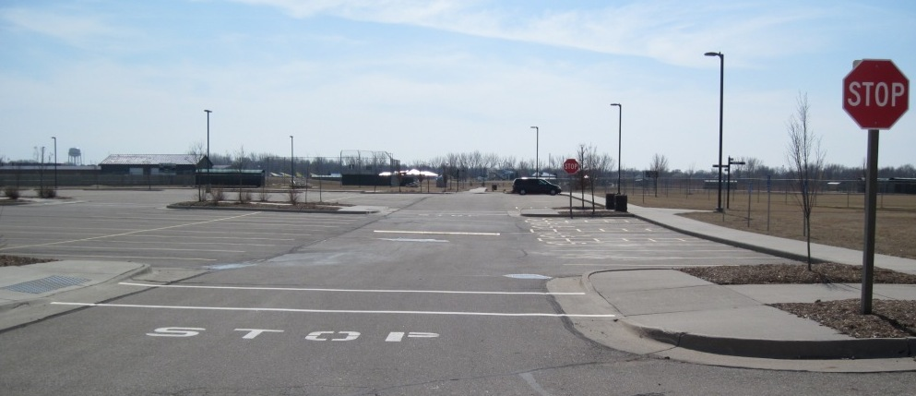

- Quad Center with awning and netting to protect spectators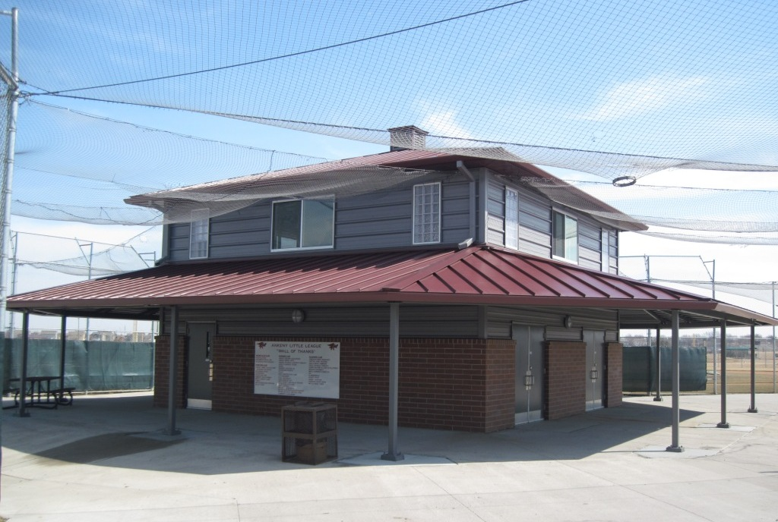

- Dark screens behind home plate for pitcher to pick up batted ball installed on all fields
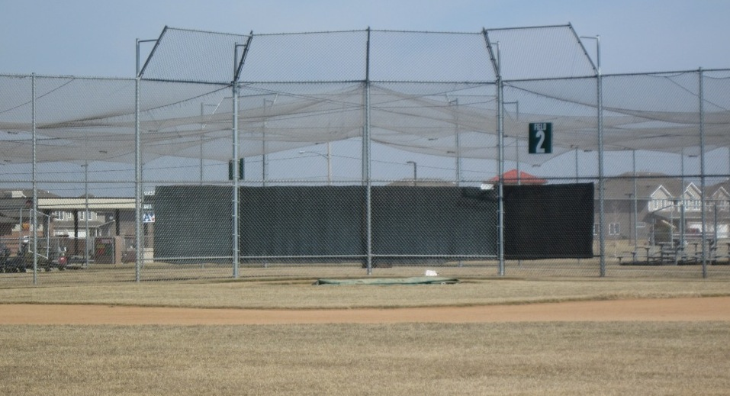

- Closed end in all dugouts to prevent players from getting hit
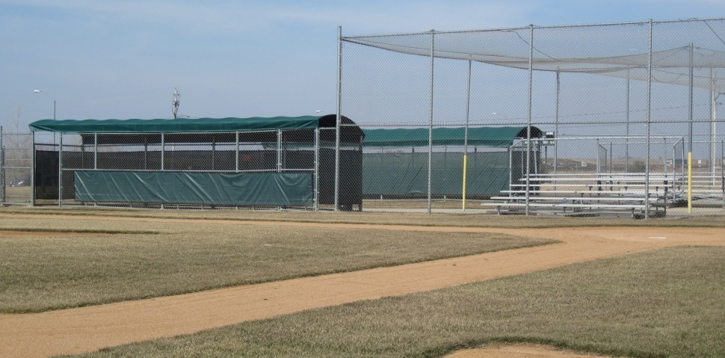

- All dugouts are covered to keep players protected from weather elements (sun, rain, etc.)
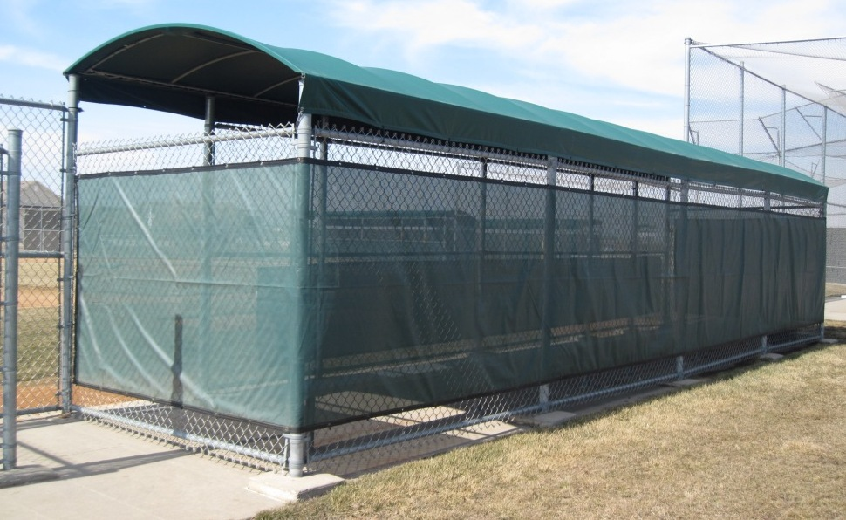

- Netting over spectators to protect from foul balls and backguard rails and side rails on bleachers
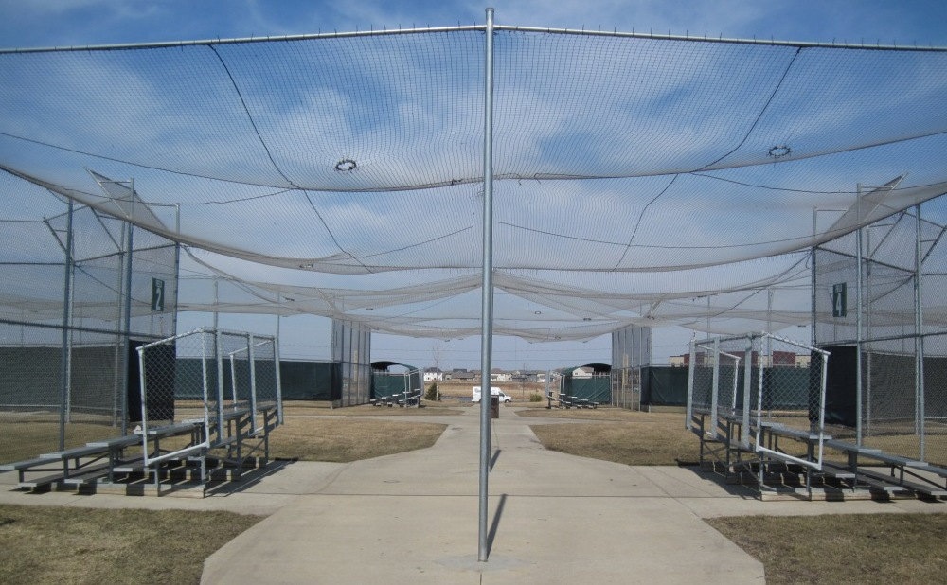

Foul ball returns installed on Fields 1-11 to aid in returning game balls to the playing field
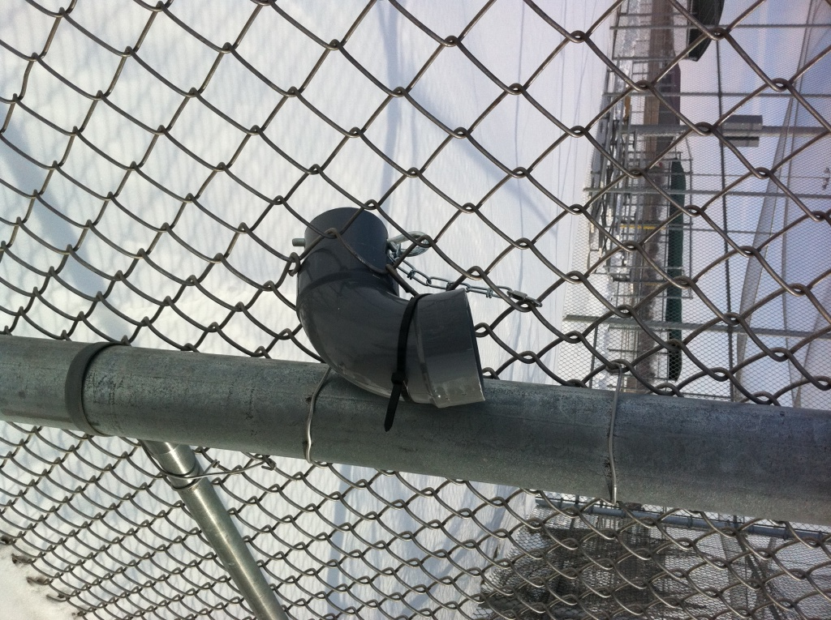

Addendums – Ankeny Little League Forms

- Ankeny Little League Incident Report Form
- Ankeny Little League Incident Reporting Instructions
- General Information About Little League Insurance
- Ankeny Little League Accident Reporting Procedure
- Little League Accident Notification and Claim Form
- Little League Accident Claim Instructions
- Little League General Liability Claim Form
- Little League Medical Release Form
- Ankeny Little League Facility Survey Form
- Ankeny Little League Severe Weather Policy

***********************

Appendices – General Safety Information

- JD Palatine (JDP) Home Safe Flyer
- Lightning Safety
- Managers and Coaches Code of Conduct
- Parents Code of Conduct
- Prairie Ridge Sports Complex Map
- Team Bag First Aid Kit Contents List
- Umpire Guidelines
- Volunteer Code of Conduct
- Concussion Training for Coaches
- Concussion Fact Sheet for Parents

